**Full Stack Development with MERN**

**1. Introduction**

* **Project Title**: House Rent Application Using MERN
* **Project Name**: Rentify
* **Team Members**:  
  + **Neha R**- Frontend
  + **Logasrimathy S** - Backend
  + **Jasmine N** - Frontend
  + **Naveen Raj K** - Backend
  + **Godwinraj T** - Frontend

**2. Project Overview**

* **Purpose**:  
  This project aims to streamline the house rental process, providing an efficient and user-friendly platform for tenants and landlords. The platform offers advanced search, simplifying property management and enhancing the rental experience.
* **Features**:
  + Responsive, user-friendly interface
  + Secure user authentication (JWT-based)
  + Admin panel for user and content management
  + Email feature to contact the owner.

**3. Architecture**

* **Frontend**:  
  Built with React.js, the frontend offers a responsive UI for users to browse properties, and handle real-time notifications. Core features include a property search page, and user login/signup functionality.
* **Backend**:  
  Developed with Node.js and Express.js, the backend provides the core functionality for user authentication, property listings. API endpoints support CRUD operations and integrate JWT for secure access.
* **Database**:  
  MongoDB is used as the database to manage user profiles, property listings. Mongoose is implemented to define schemas, enforce data validation, and manage interactions with MongoDB collections.  
    
    
    
    
    
  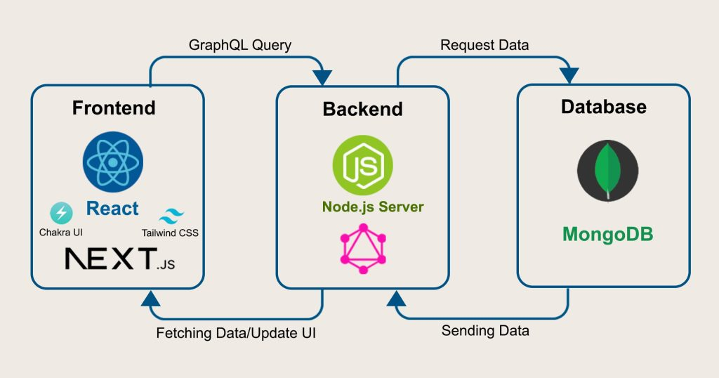

**4. Setup Instructions**

* **Prerequisites**:
  + Node.js
  + MongoDB
  + npm or yarn
* **Installation**:
  + Clone the repository: git clone <repository-url>
  + Navigate to the client and server directories.
  + Install dependencies:
    - **Frontend**: npm install in the client directory
    - **Backend**: npm install in the server directory
  + Configure environment variables in .env files (e.g., MongoDB URI, JWT secret).

**5. Folder Structure**

* **Client**:
  + src: Contains the main React components, pages, and styles.
  + components: Includes reusable components like Navbar, Search, PropertyCard, etc.
  + pages: Contains main pages such as Home, and Property Details.
  + services: Handles API requests and state management for different features.
* **Server**:
  + controllers: Manages logic for user authentication, property.
  + models: Defines schemas for users and properties.
  + routes: Organizes API endpoints, such as /api/users, /api/properties, and /api/bookings.
  + config: Contains configuration for MongoDB and JWT.

**6. Running the Application**

* **Frontend**:  
  Start the frontend server in the client directory: npm run dev
* **Backend**:  
  Start the backend server in the server directory: npm start

**7. API Documentation**

* **Users**:
  + POST /api/users/register: Registers a new user.
  + POST /api/users/login: Authenticates user and provides a JWT token.
* **Properties**:
  + GET /api/properties: Fetches all properties based on filters.
  + POST /api/properties: Allows landlords to add new properties.

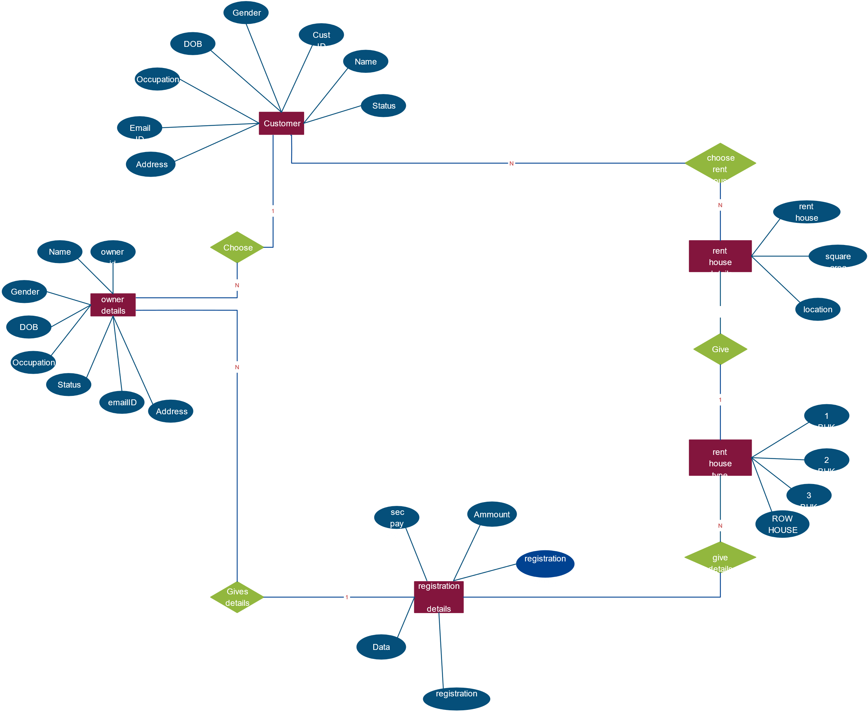

**8. Authentication**

* **Method**:  
  JWT-based authentication. Users receive a JWT token upon login, which is required to access protected routes. Role-based access controls differentiate permissions between tenants and landlords.

**9. User Interface**

* **Overview**:  
  The UI includes pages like the registration page, home page, login page, property details. These pages are responsive and provide intuitive navigation for both tenants and landlords.

**10. Testing**

* **Strategy**:
  + Unit testing for individual components using Jest.
  + Integration testing for API endpoints.
  + End-to-end testing for major user flows.

**11. Screenshots or Demo**  
**Demo Link:** [Rentify Demo Video](https://drive.google.com/drive/folders/10HY1tyzid7Mvp22c6PzmVXA0oHI-wlCo)

**Screenshots:**  
  
  
**Registration Form:**

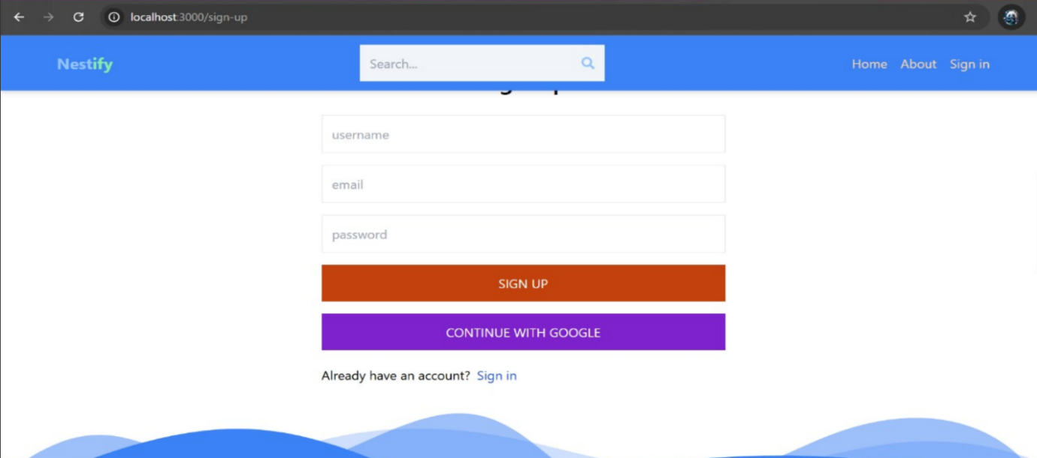  
  
  
 **Home Page**  
  
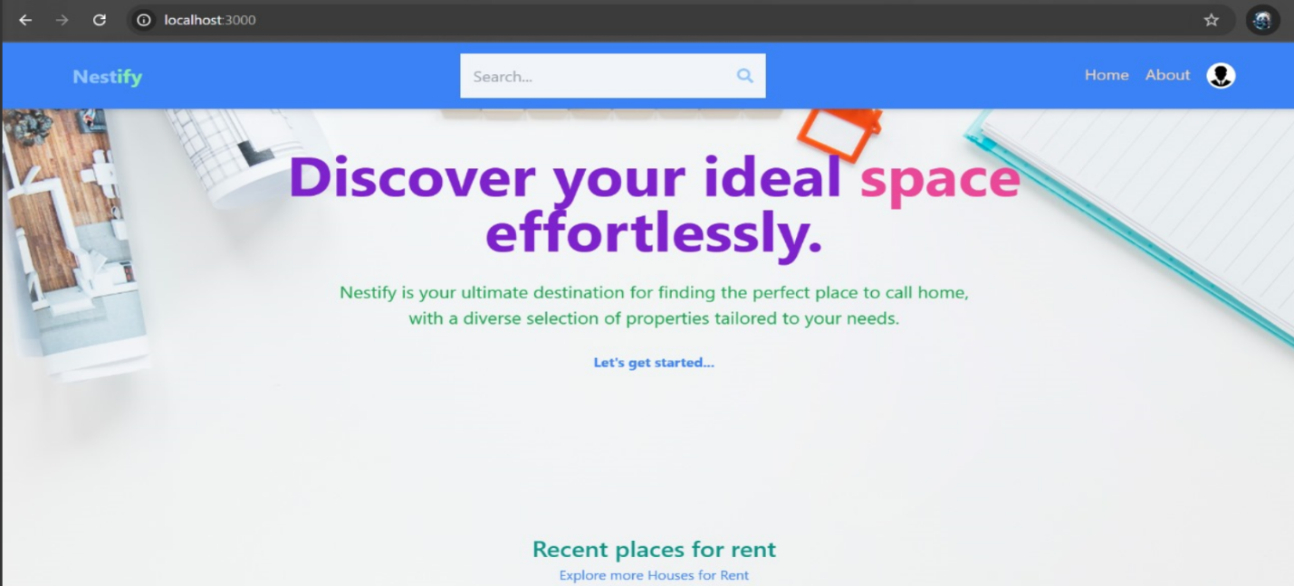

**Login Page  
  
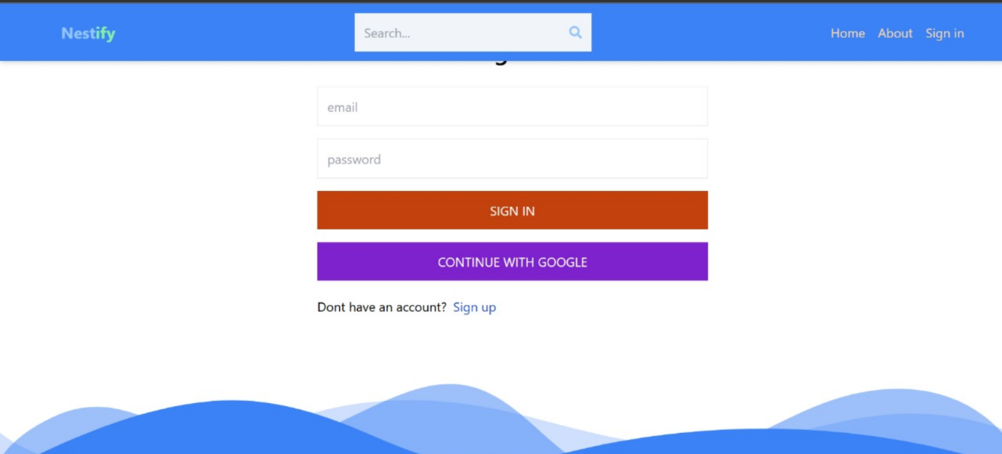**

**Property Details**  
  
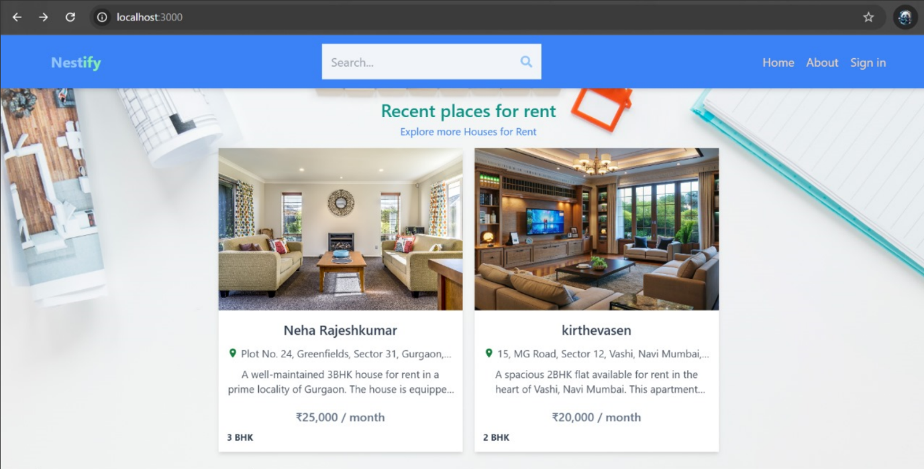

**Owner Contact:  
  
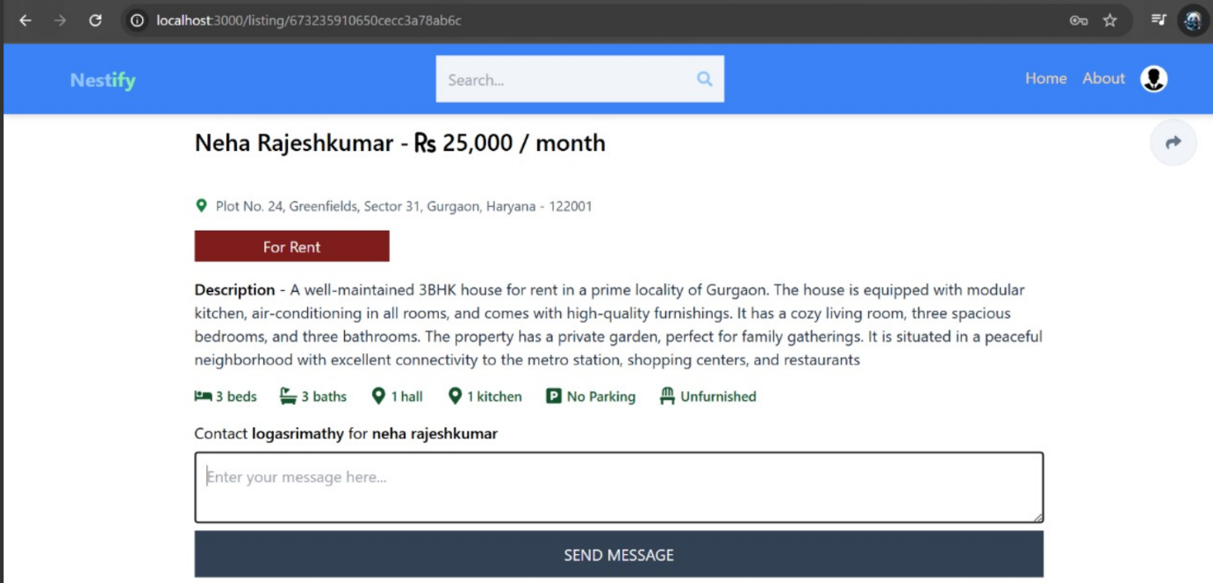**

**12. Known Issues**

* High traffic may cause slowdowns if the backend is not optimized.
* Email feature may experience delays under high load.

**13. Future Enhancements**

* Advanced search and filtering options
* User profile customization
* Mobile app version
* Multilingual support
* Automated booking and payment processing